**Laptop Price Prediction Using**

**Machine Learning**



**Submitted By**

**Nitin**

**CONTENTS**

1. Introduction.......................................................................................................... 3

2. Problem..................................................................................................................3

3. Methodology..........................................................................................................4

4. Results………………………................................................................................9

5. Deployment..................……..…………………………………………………..11

6.Conclusion……………........................................................................................16

7. Appendix………………......................................................................................17

8. Reference …………………………………………………………………...….19

**Introduction:**

This dataset contains information about various laptops and their specifications, such as brand, processor type, RAM size, storage, screen size, operating system, and more. The main goal is to predict the price of a laptop based on these features. It can be used for machine learning models, regression analysis, and market research.

**1.Problem**:

* 1. **What problem are you solving?**

We are trying to analyse and predict the price of laptops based on their specifications and features. This involves understanding how various hardware and software characteristics (like CPU, RAM, GPU, etc.) influence the final market price of a laptop.

* 1. **Why is it worth solving?**
* **Consumer Decision-Making**: Buyers can make informed purchasing decisions based on what specifications offer the best value for their budget.
* **Retail Strategy**: Sellers can adjust pricing strategies or identify competitive product configurations.
* **Market Analysis**: Useful for researchers or companies to understand price trends and factors influencing price fluctuations.
* **Recommendation Systems**: Can be used to build systems that suggest laptops based on a user’s budget or requirements.

**1.3 What are the requirements for crafting a solution for this problem?**

* **Data Exploration**: A thorough examination of the dataset to uncover patterns, insights, and relationship among different features.Using charts like boxplot, scattered, etc., to gain relationship insights.
* **Data Cleaning**: Handle missing values and inconsistencies.Remove unwanted columns
* **Feature Engineering**: Convert categorical variables into numeric formats using encoding, and scaling data.
* **Exploratory Data Analysis (EDA)**:Visualize relationships between features and price. Identify outliers or patterns in the data.
* **Modelling**: Select and train machine learning models (e.g., Linear Regression, Random Forest, XGBoost).Evaluate model performance using metrics like RMSE or R².
* **Deployment** (optional): Build a simple web app or tool where users can input laptop specs and get a predicted price.
  1. **Data Source**: Kaggle.com

**Link**: <https://www.kaggle.com/datasets/eslamelsolya/laptop-price-prediction/data>

**1.4 Data Dictionary:**

|  |  |  |
| --- | --- | --- |
| **Column Name** | **Description** | **Data Type** |
| Company | The manufacturer or brand of the laptop (e.g., Dell, HP, Lenovo). | String |
| TypeName | The category/type of the laptop (e.g., Ultrabook, Gaming, Notebook). | String |
| Inches | The screen size of the laptop in inches. | Float |
| ScreenResolution | The resolution of the screen (e.g., 1920x1080, 1366x768). | String |
| Cpu | The processor details (e.g., Intel Core i5 7200U). | String |
| Ram | The amount of RAM in gigabytes (e.g., 8GB). | String |
| Memory | Storage configuration (e.g., 256GB SSD, 1TB HDD). | String |
| Gpu | Graphics card details (e.g., Nvidia GTX 1050, Intel UHD 620). | String |
| OpSys | Operating system installed (e.g., Windows 10, macOS, Linux). | String |
| Weight | Weight of the laptop in kilograms (e.g., 2.1kg). | String |
| Price | The price of the laptop in the dataset's currency. | Float |

*Also, check Appendix 6.2 for datatypes*

1. **Methodology:**
   1. **How did you solve the problem?**

Using CRISP-DM, which stands for Cross-industry Standard Process for Data Mining, is the most widely used open standard process model - if a process model is used at all, of course. CRISP-DM defines a set of phases that make up a data science project. Most importantly, transitions between those phases are bidirectional and the whole process is iterative. This means that after you've reached the final stage that you just start the whole process again and refine your work. The following figure illustrates this process.

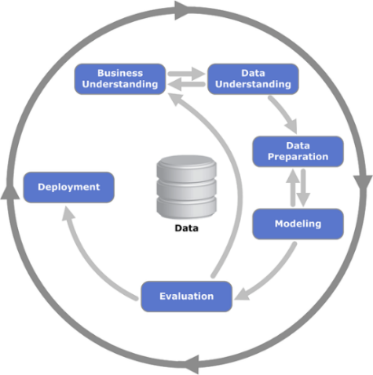

[**https://developer.ibm.com/articles/architectural-thinking-in-the-wild-west-of-data-science/**](https://developer.ibm.com/articles/architectural-thinking-in-the-wild-west-of-data-science/)

* 1. **Business Understanding:**

The goal was to build a machine learning model that can predict the price of a laptop based on its specifications. This would help consumers, retailers, and analysts make informed decisions about value, pricing, and configuration preferences.

**2.3What exploratory analysis, data engineering, or data wrangling did you need to do?**

**Data Understanding (EDA)**: We examined the dataset containing various laptop features such as brand, screen size, resolution, processor, RAM, storage type, graphics card, operating system, weight, and price. All the columns in the dataset are positively skewed and from the diagrams below we can see some of the distribution of the datasets showing positive skew.

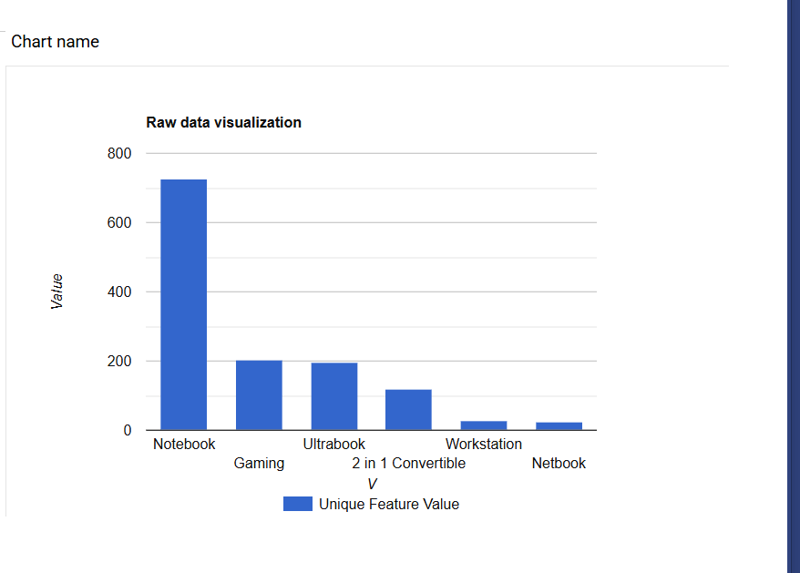 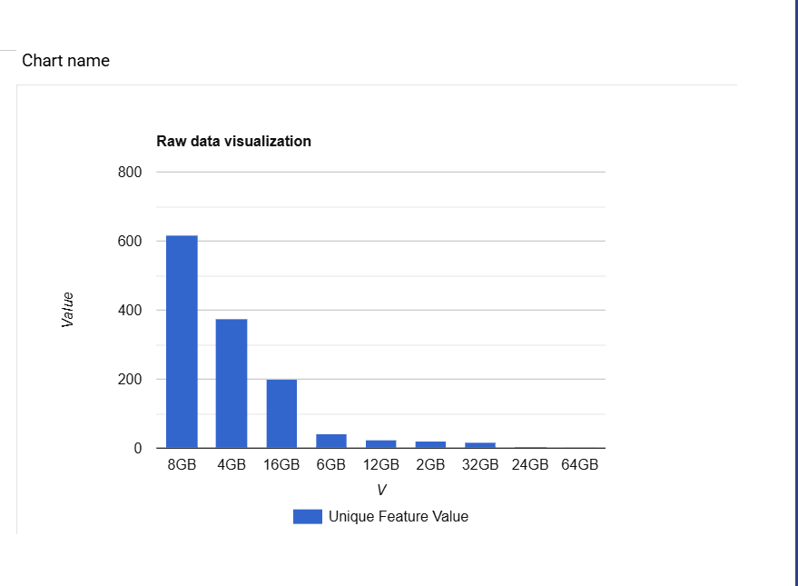

**Laptop TypeName distribution Memory distribution**

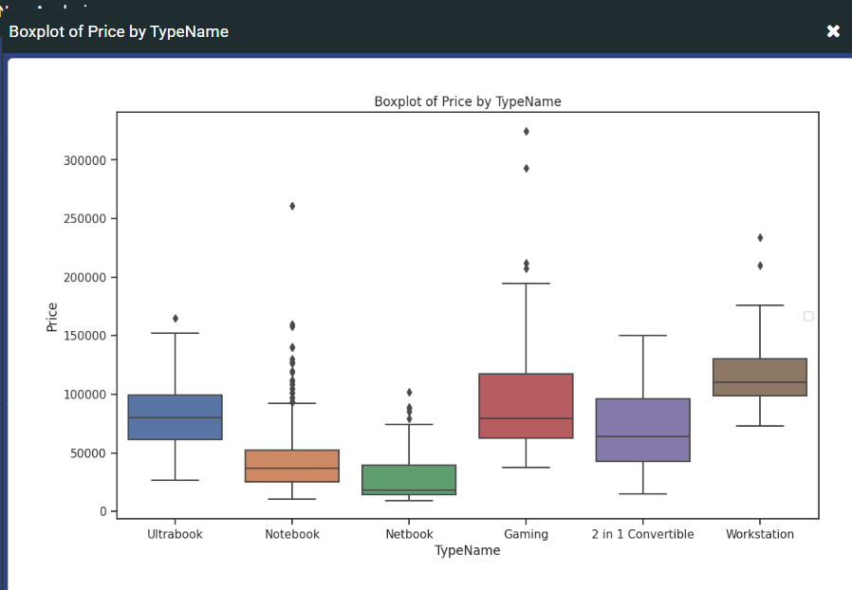 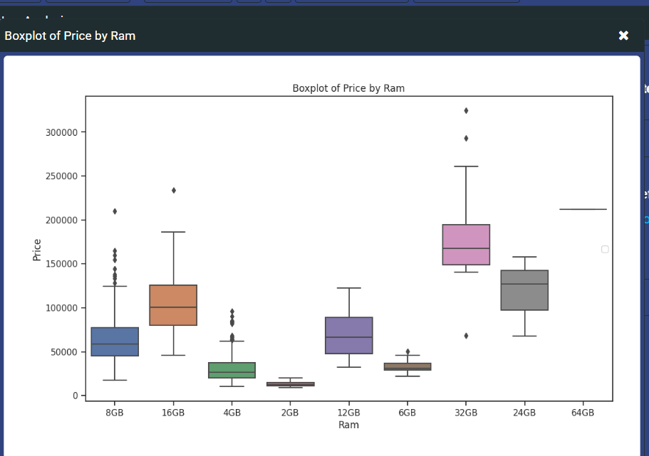

**Boxplot of Laptop Price by Type Boxplot of Laptop Price by Ram**

**Relationships:** for example, using the boxplot we can see from the above diagram how Laptop type or Ram affects price.Trends and outliers in numeric and categorical data: Also see Appendix 6.4.

* 1. **Data Preparation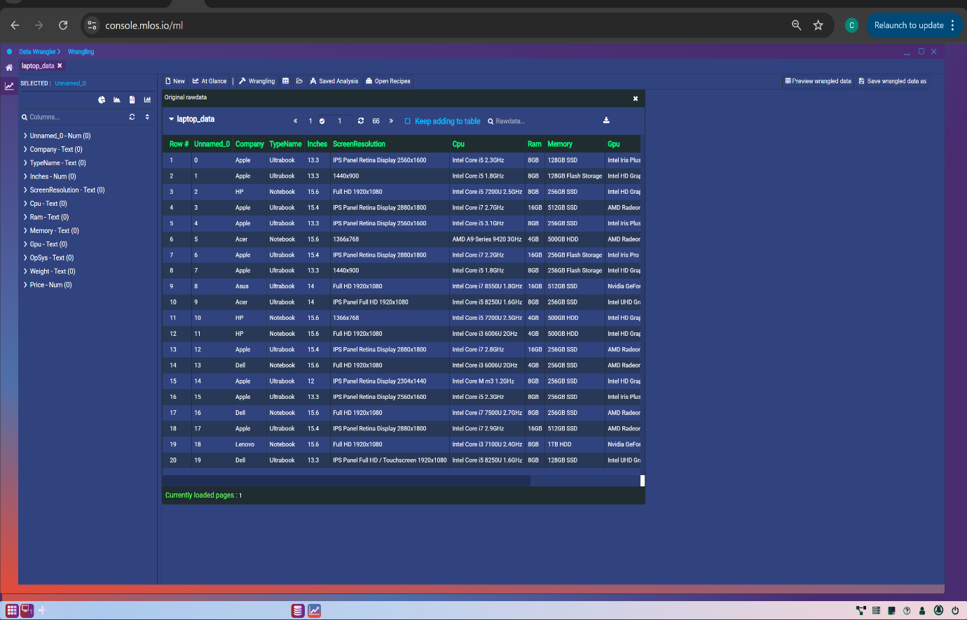:** Data wrangling and feature engineering were performed to get the dataset ready for modelling: Handled missing data (if present). In the diagram below, the columns on the left-hand side show (0) missing values (NULL). Therefore, the dataset has no missing value. *Also, see appendix 6.3*

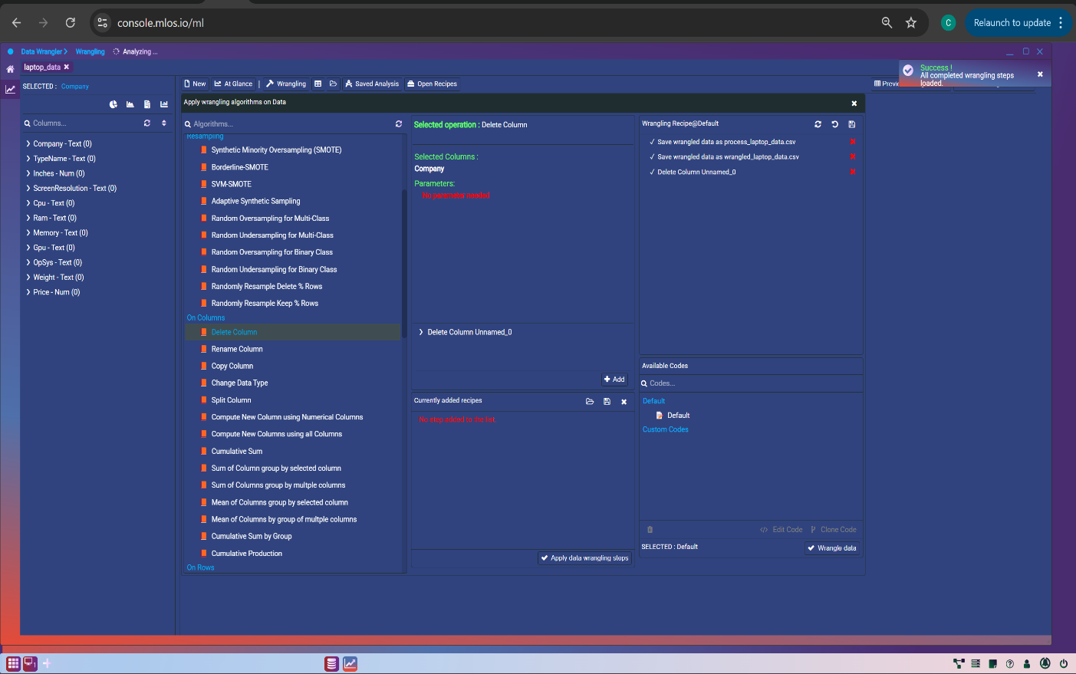

Remove unnecessary columns like (Unnamed)

**Defining the Dataset:** Selecting input and Output Variables - we selected the Price column as the Target variable (output) and other columns as the Future variable (input).

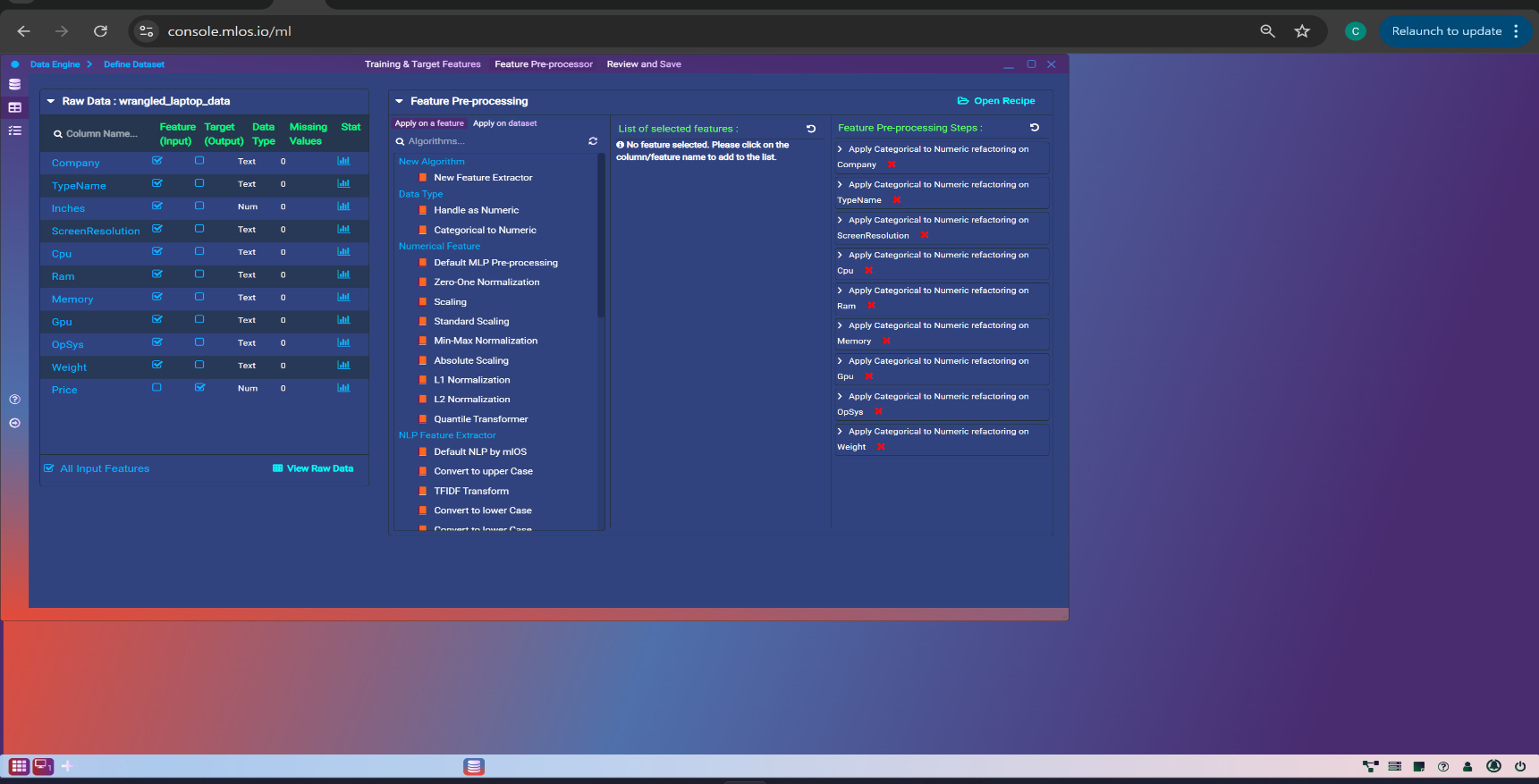

Feature Pre-processing Steps: apply Categorical to Numerical refactoring on all the feature variables (input).

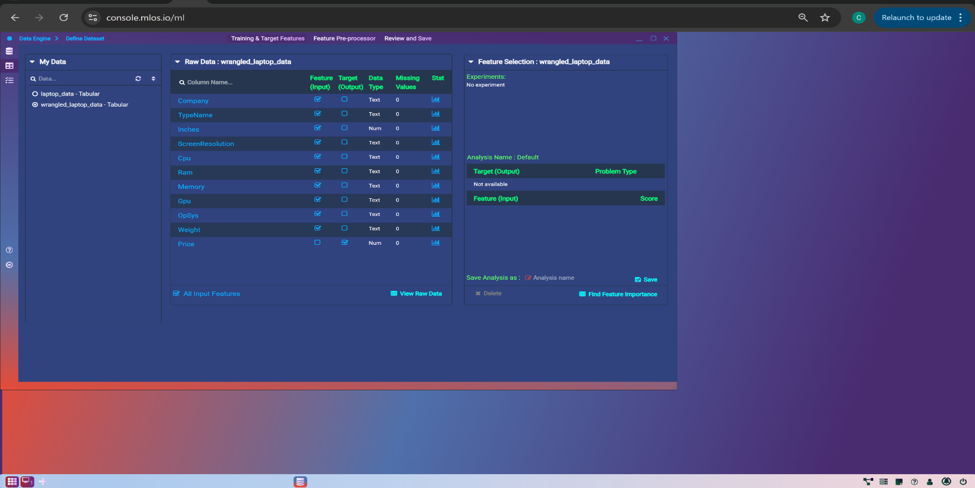

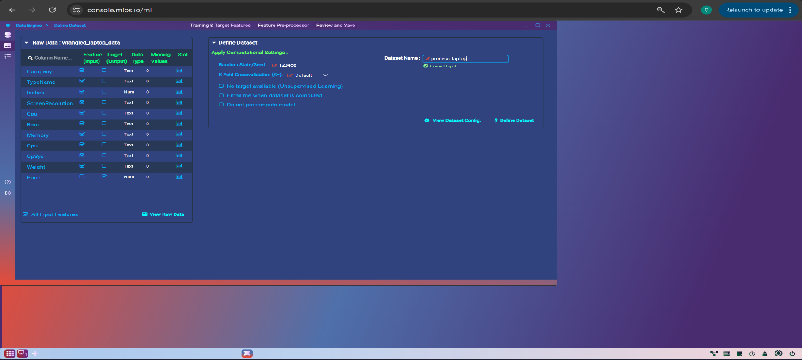Split the dataset into 80% training and 20% testing sets by defining the dataset.

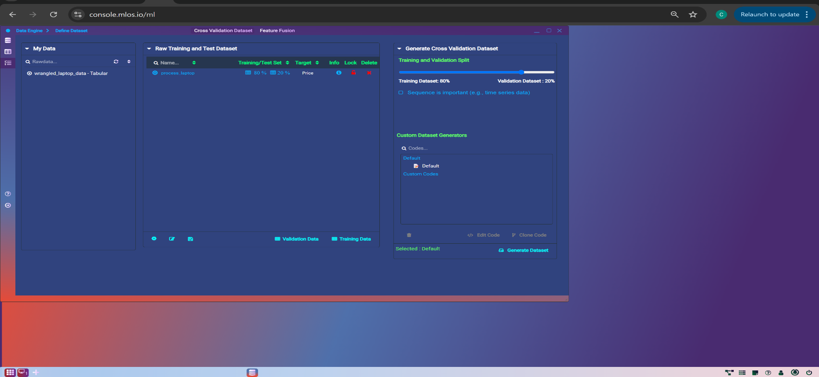

**2.5 What was your modelling process? Specifically, which algorithms and parameters did you use and why?**

**Modelling:** Supervised Learning using Regression

After completing data cleaning and exploratory analysis, we moved on to building predictive models to estimate laptop prices. We used three tree-based regression algorithms:

**Random Forest Regressor:**

**Why this algorithm?**  
Random Forest is an ensemble learning method that combines the predictions of multiple decision trees to improve accuracy and reduce overfitting. It's robust, handles both numerical and categorical data well, and captures complex interactions between features.

**Strengths:** Performs well on most regression problems**.** Reduces variance and overfitting seen in single trees**.** Automatically handles feature importance

**Extra Tree Regressor (Extremely Randomized Trees):**

**Why this algorithm?**

Extra Trees is similar to Random Forest, but it introduces more randomness in how splits are made. Instead of finding the best threshold, it chooses random cut-points, making it faster and potentially more diverse.

**Strengths:** Faster than Random Forest (less computation at each split)**.** Can reduce variance and avoid overfitting**.** Useful for high-dimensional data

**Weakness:** More randomness can lead to less accurate models compared to Random Forest, depending on the dataset

**Decision Tree Regressor:**

**Why this algorithm?**  
This is a simple, interpretable model that works by splitting the data into regions based on feature thresholds. It’s useful as a **baseline model** to understand how tree-based models behave.

**Strengths:** Easy to understand and visualize**.**Fast training time**.**Good for initial experimentation

**Weakness:** High tendency to overfit on training data**.** Poor generalization compared to ensemble methods like Random Forest

1. **Results:**
   1. **What were the results?**

**Model Performance Summary Table**

|  |  |  |  |  |
| --- | --- | --- | --- | --- |
| **Model** | **Mean Squared Error (MSE)** | **Mean Absolute Error (MAE)** | **Mean Squared Log Error (MSLE)** | **Median Absolute Error** |
| **Random Forest Regressor** | 15,272.49 | 9,592.39 | 0.0436 | 6,124.97 |
| **Extra Tree Regressor** | 19,059.46 | 11,444.49 | 0.07088 | 6,175.15 |
| **Decision Tree Regressor** | 19,235.55 | 11,567.10 | 0.07418 | 5,860.80 |

* 1. **Model Performance Explanation**

**Random Forest Regressor:** Best performer overall with the lowest errors across MSE, MAE, and MSLE.Captures non-linear relationships and interactions between variables.Handles feature importance and outliers well.Recommended model for predicting laptop prices in this case.

**Extra Tree Regressor :** Performs slightly worse than Random Forest.Though it’s similar to Random Forest, Extra Trees use random splits at each node, which can make it more unstable and less accurate in some cases.MSE and MAE are higher, indicating less precise predictions.

**Decision Tree Regressor:** Has the highest error rates overall.Tends to overfit the training data and perform poorly on unseen data (i.e., high variance).Suitable as a baseline or for feature interpretation, but not ideal for final predictions.

**3. 3Random Forest Graph Analysis:**

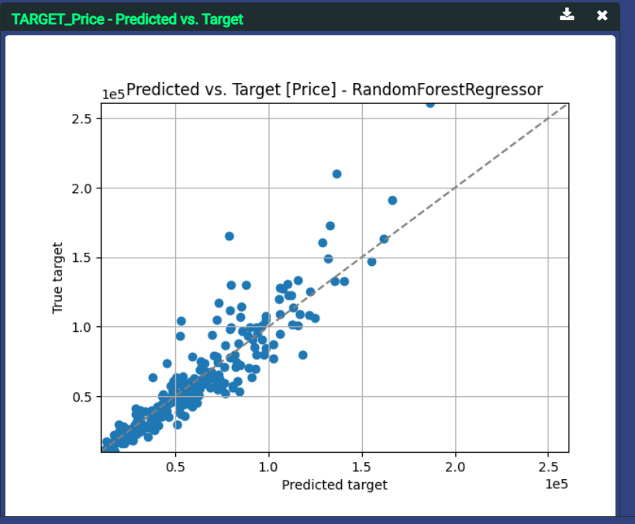 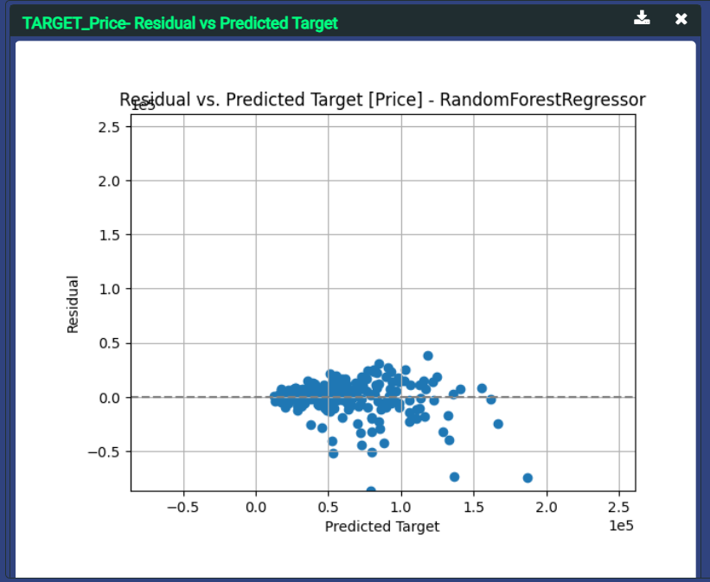

**Target_Price Predicted vs Target Target_Price Predicted vs Residual**

* 1. **Random Forest Original Vs Predicted**

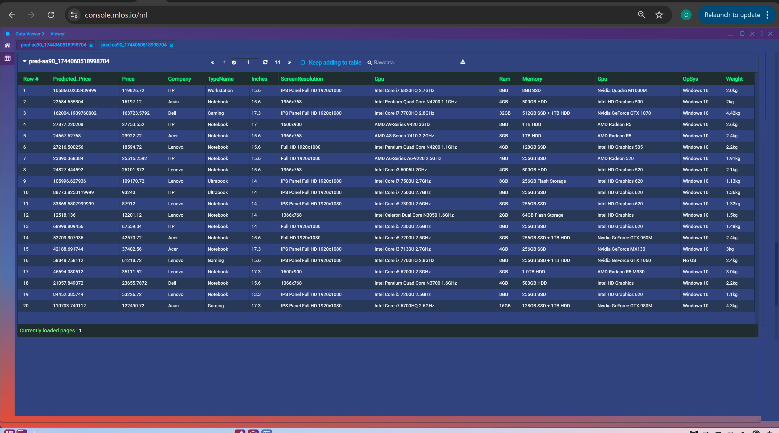

* 1. **How did you evaluate the performance of your model? What metrics did you use?**

**Evaluation:** Models were evaluated using:

**Root Mean Squared Error (RMSE):** MSE is the average of the squared differences between the actual and predicted values. Because it squares the errors, it penalizes large errors more heavily. This makes it useful when large prediction mistakes are especially bad. It’s commonly used for comparing regression models since it gives more weight to significant deviations.

**Mean Absolute Error (MAE):** MAE is the average of the absolute differences between actual and predicted values. Unlike MSE, it treats all errors equally, without squaring them. It’s more interpretable because it's in the same units as the target variable (e.g., dollars if you're predicting price), and it’s less sensitive to outliers than MSE.

**Mean Squared Log Error (MSLE):** MSLE measures the squared difference between the logarithm of the actual and predicted values. This metric is useful when the target variable spans a large range or has exponential growth, such as prices that vary significantly. It also penalizes under-predictions more than over-predictions, which can be useful depending on your use case.

**Median Absolute Error:** This is the median of all the absolute differences between predicted and actual values. It’s especially useful when your dataset has outliers, because it focuses on the typical or central error, rather than being influenced by extreme values like MSE or MAE. It gives a good sense of what the “usual” prediction error is.

1. **Deployment *(Optional, based on project scope)***

The model can be deployed in a simple web app or API to allow users to input specs and get an estimated price instantly.

* 1. **Model Governance**

After completing the modelling phase, the trained models, evaluation metrics, and performance insights were compiled and presented to our course instructor for review and approval. This step ensures accountability, transparency, and quality assurance in the modelling process.

The modelling approach (including algorithm selection, data preprocessing, and feature engineering) was clearly documented. A thorough explanation of the model performance using metrics such as Mean Squared Error (MSE), Mean Absolute Error (MAE), and Mean Squared Log Error (MSLE) was included to justify model selection. The Random Forest Regressor was highlighted as the best-performing model based on both accuracy and robustness, making it the primary candidate for deployment or further use.

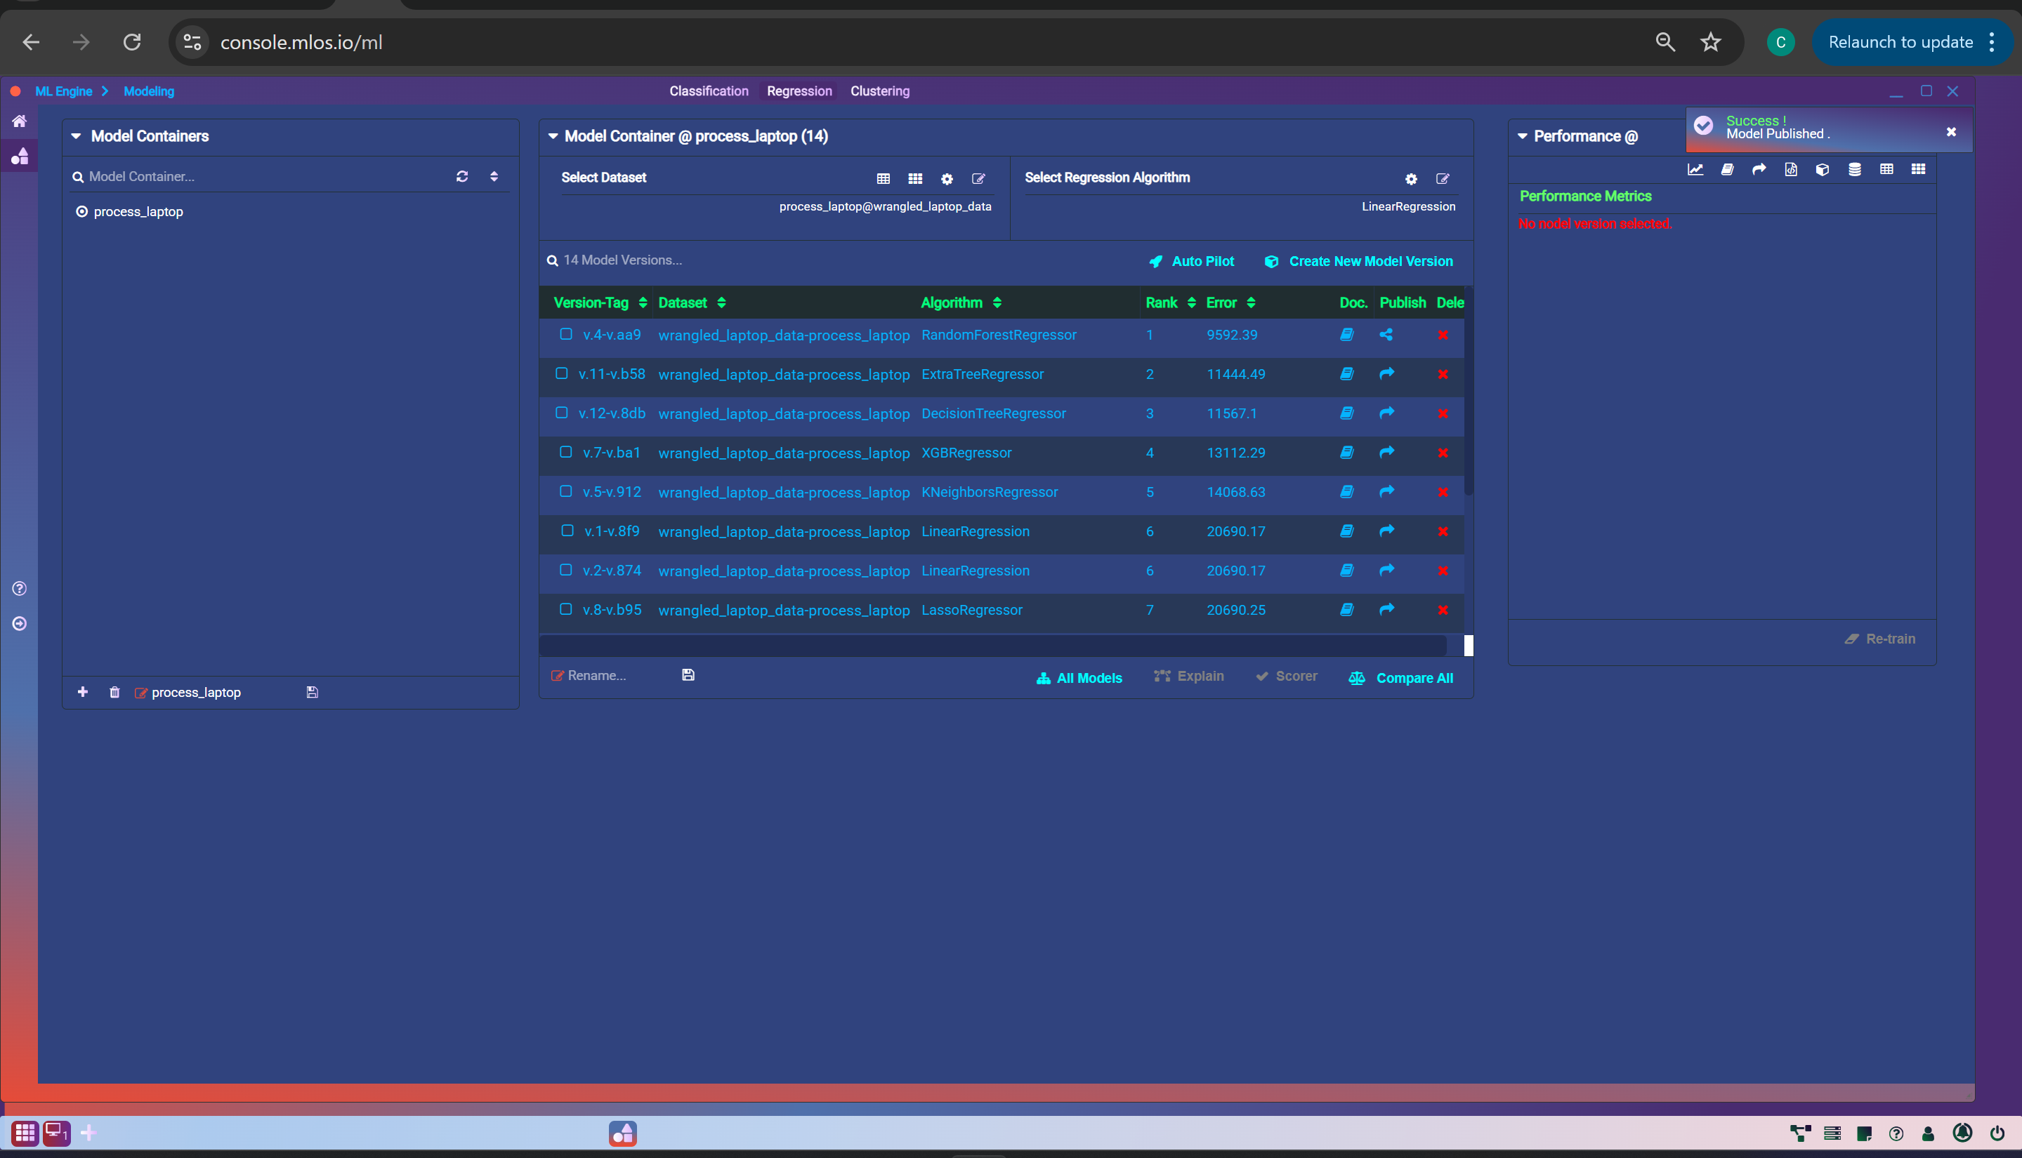

**Publishing model to instructor**

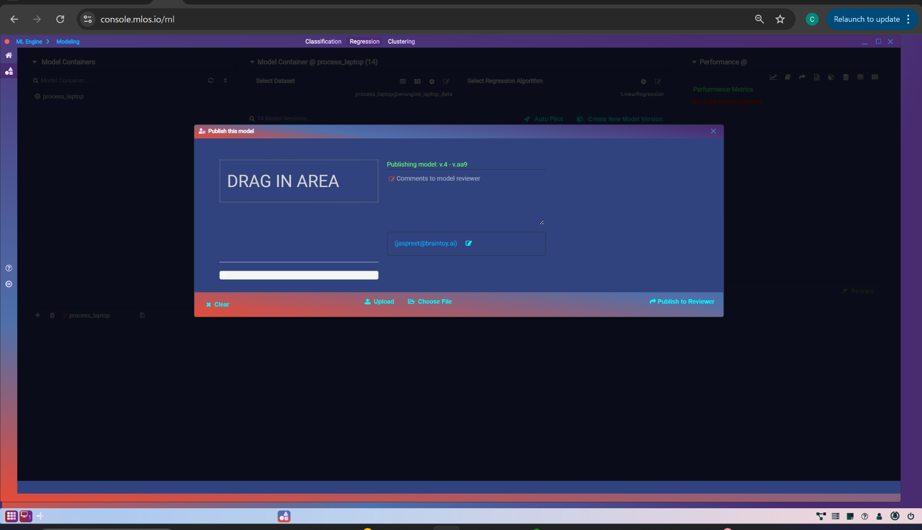

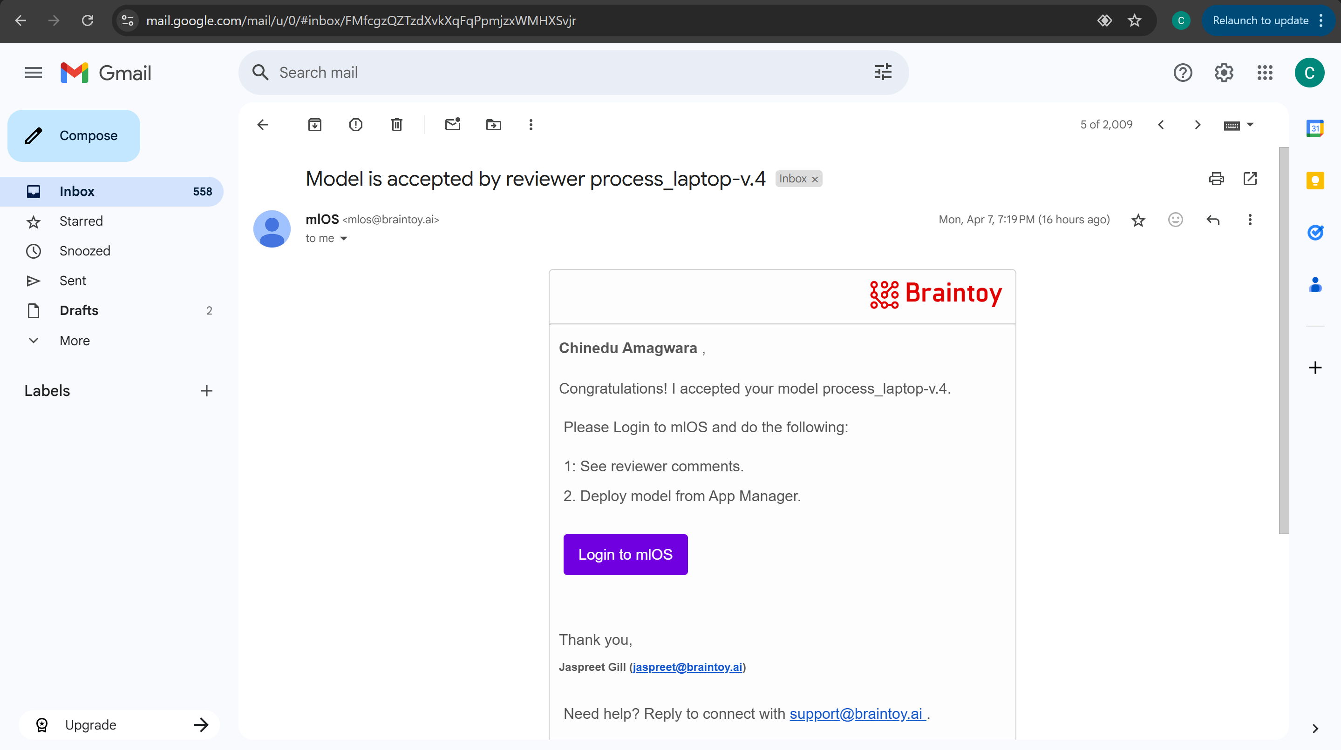

**Model Approved**

* 1. **Model Deployment**

**Deploying the Application and Model (Random Forest Regressor):**To begin creating the application, we navigate to Manage Apps and click on Add App. This process allows us to generate a new app container, which serves as the workspace for linking models and generating API keys. It’s important to note that App Management is strictly used for creating the app structure and managing access credentials, not for deploying or running the model directly.

**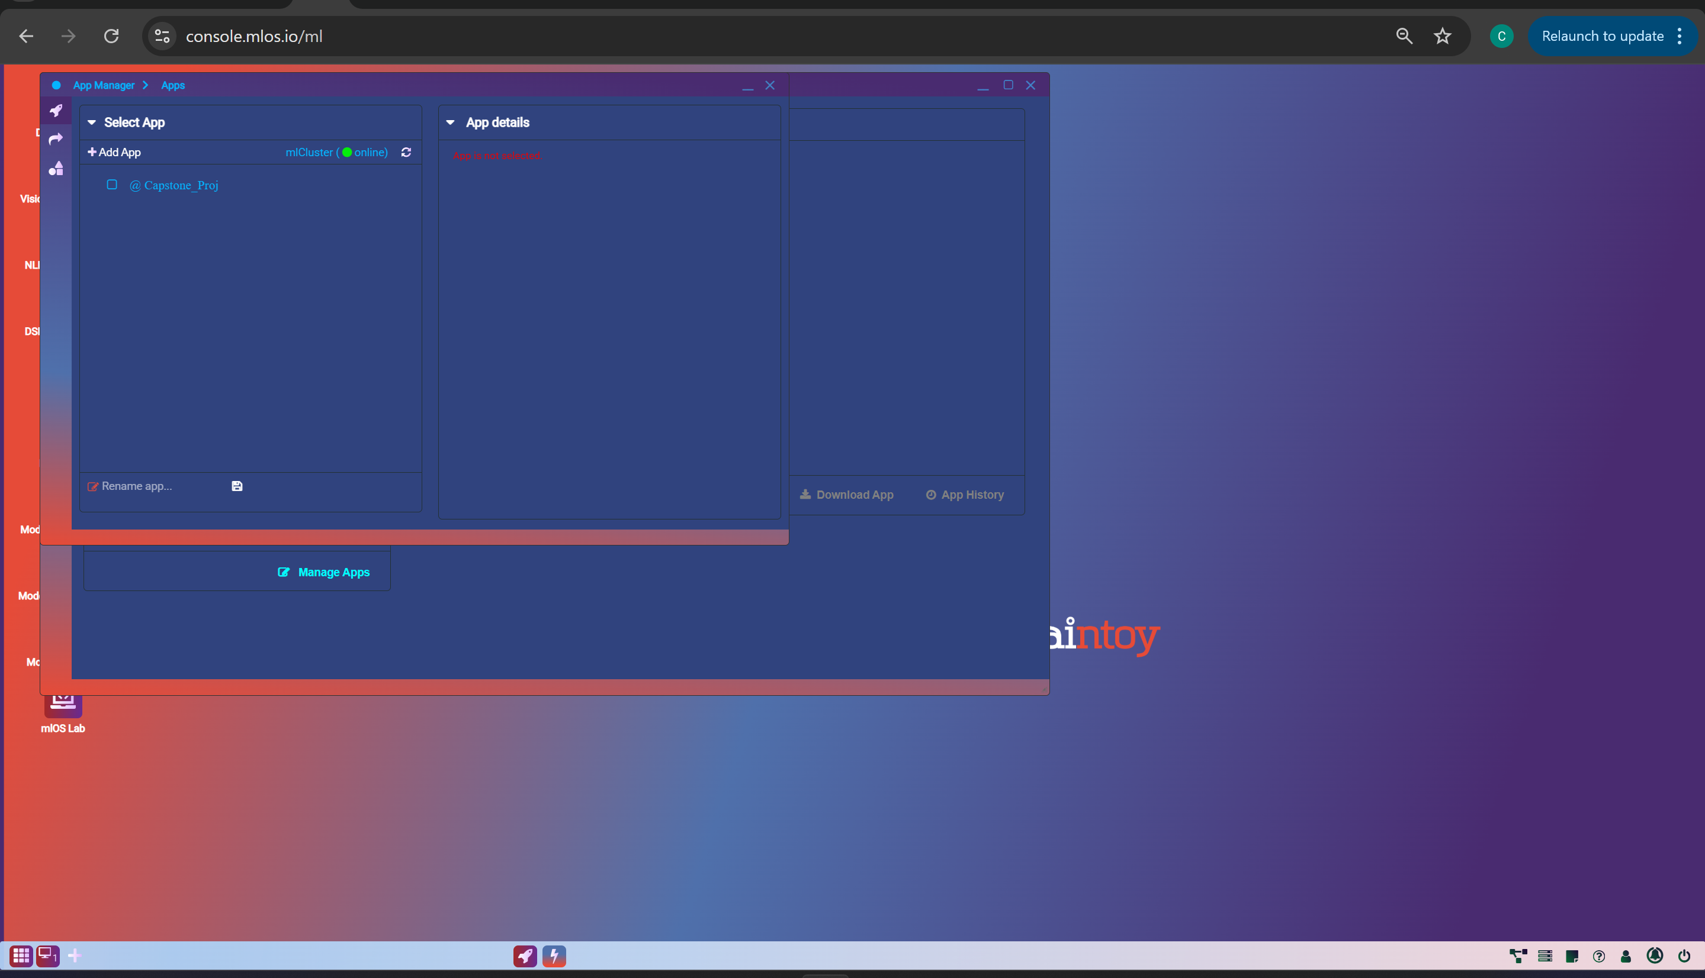****Creating Container for the app (a)**

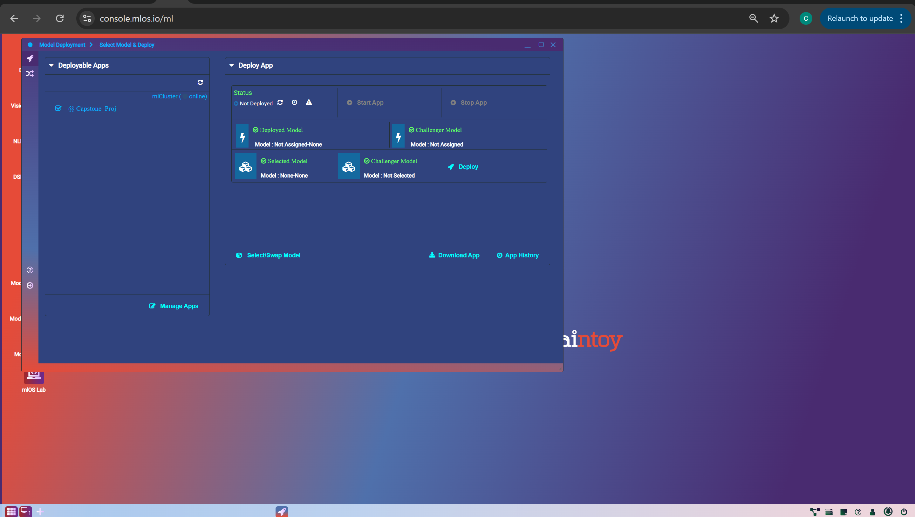

**Creating Container for the app (a)**

**Selecting and Deploying the Random Forest Model:** Within the newly created app container, we proceed by clicking on Select/Swap Model. Under the Regression category, we can see the list of trained models that are available. We locate our previously approved Random Forest Regressor and select Deploy this model, followed by confirming the deployment.

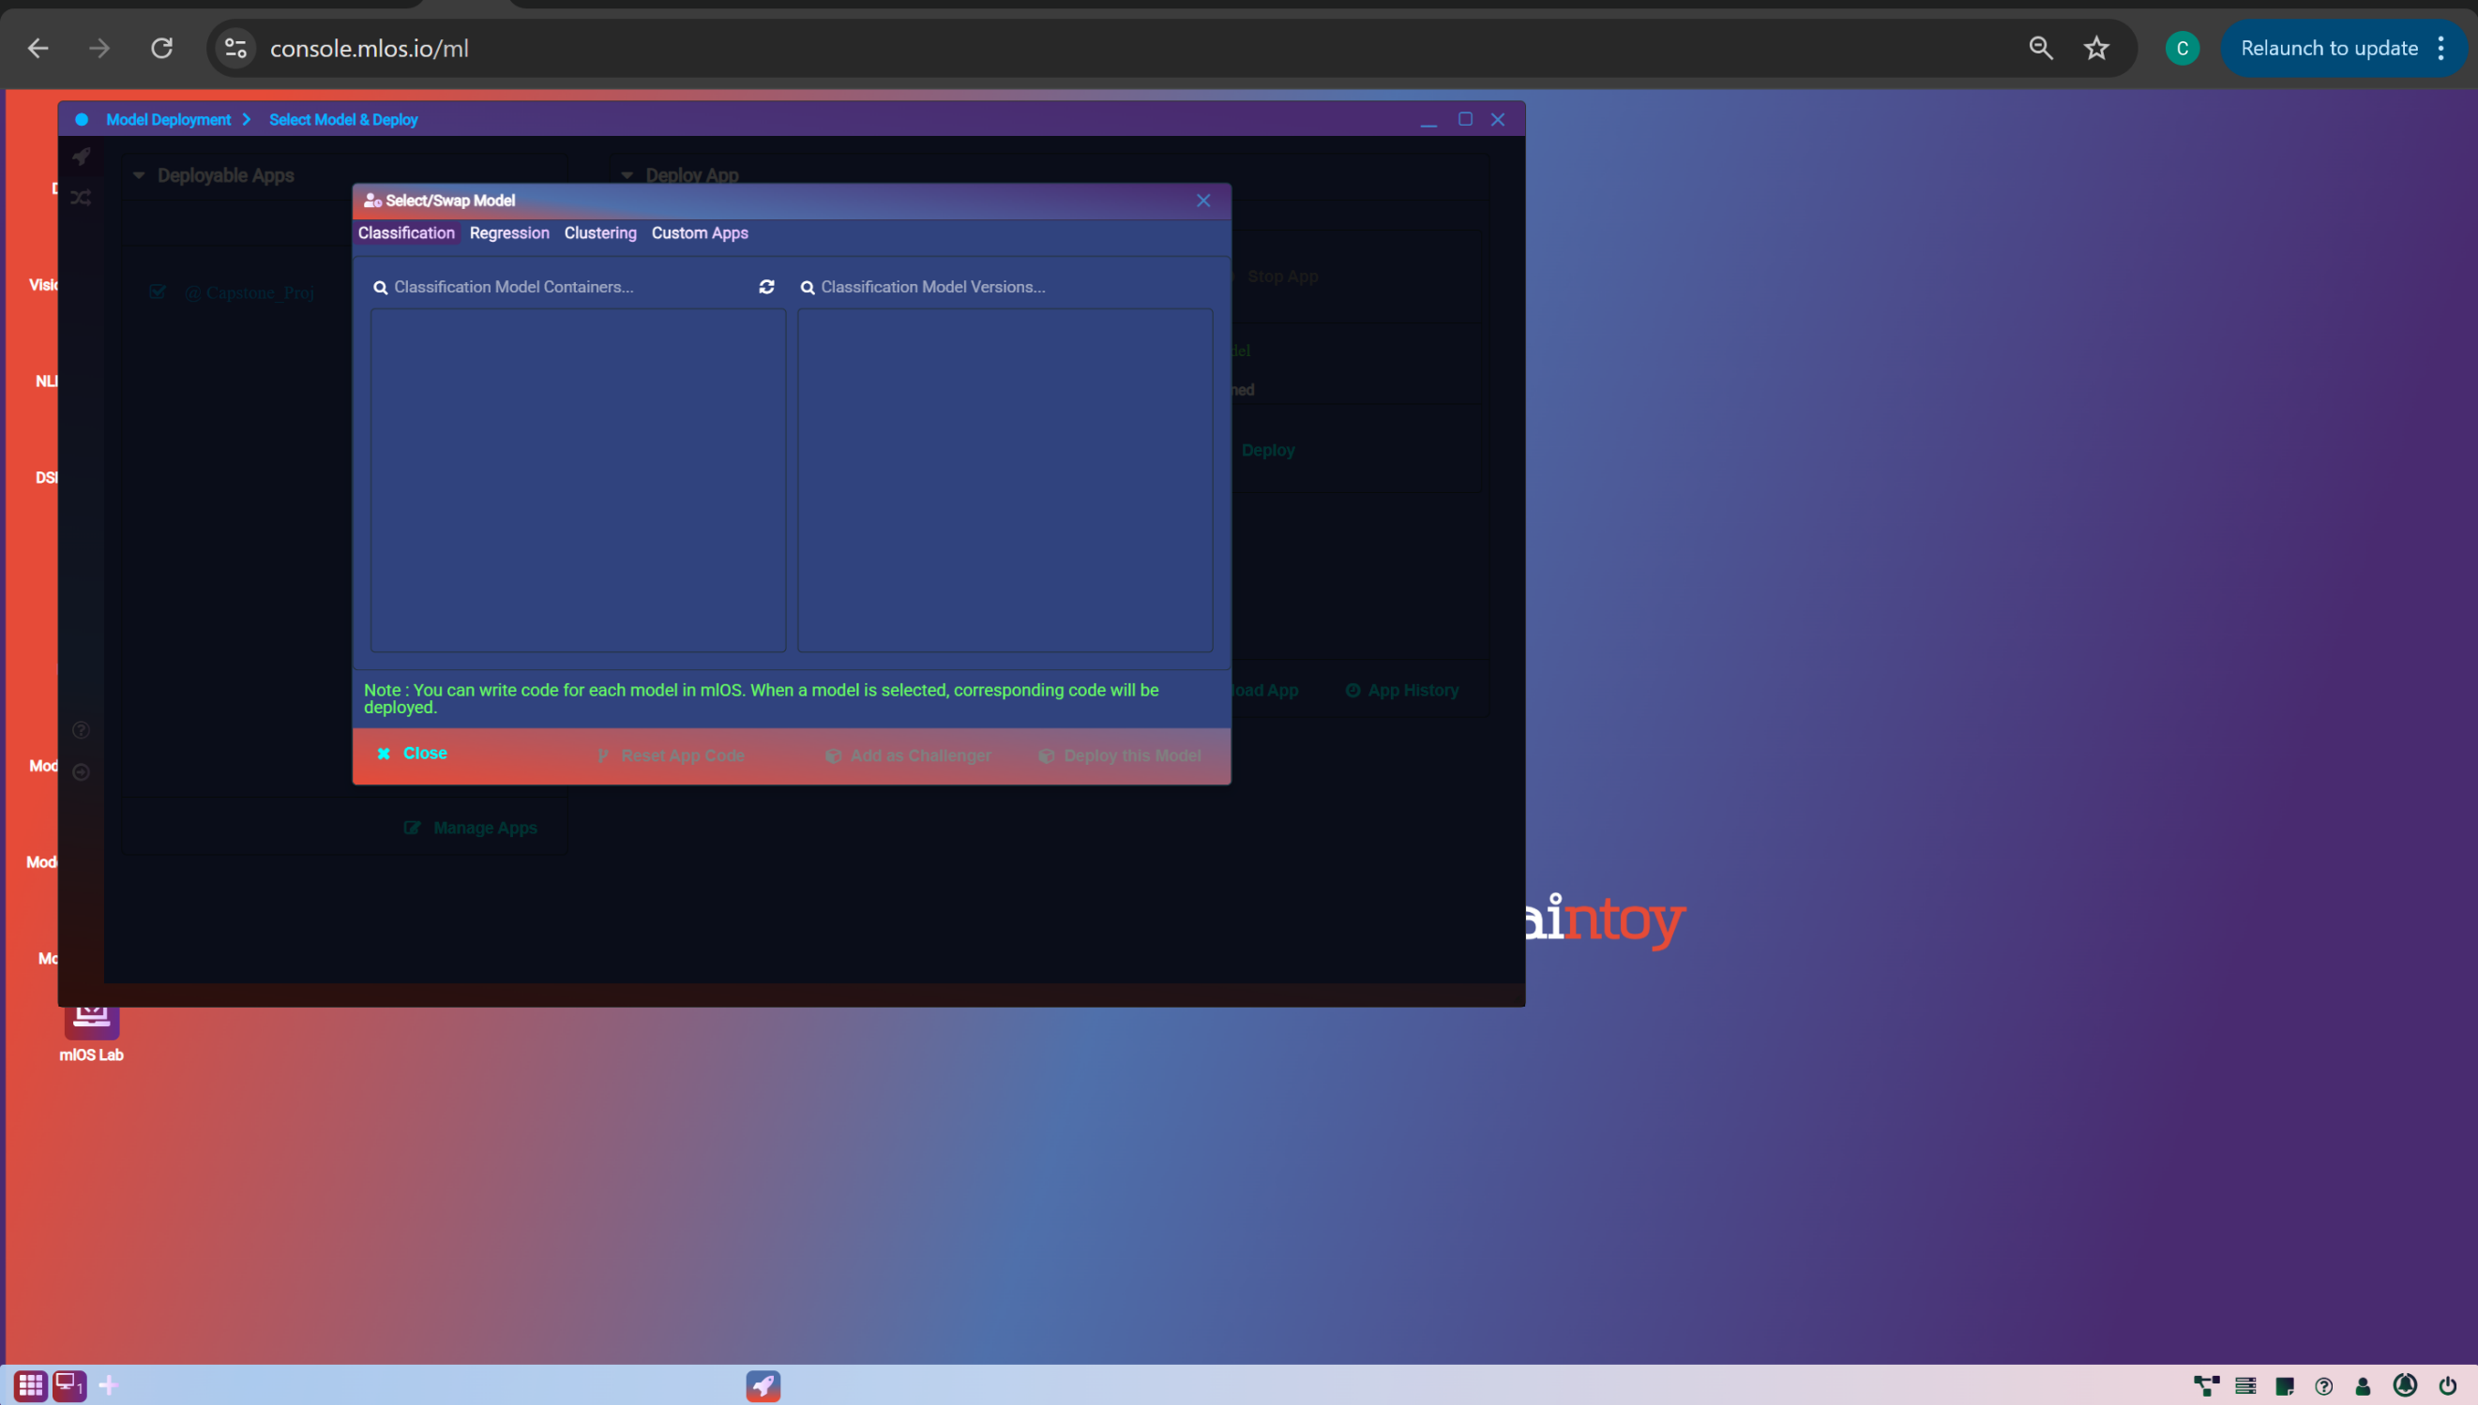**Select/Swap Model (a)**

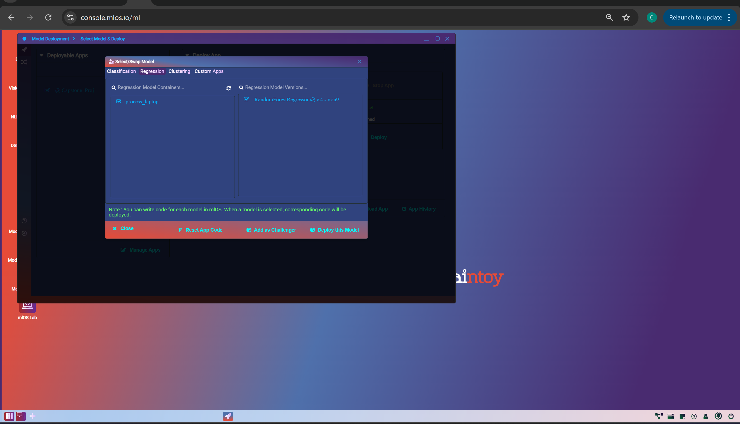

**Select/Swap Model (Regression)**

Once deployed, the interface will update to indicate that the model is now active within the app container.

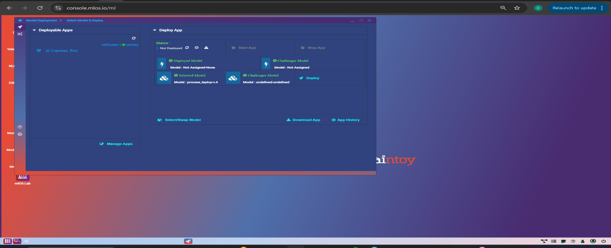 **Selected model for deployment**

*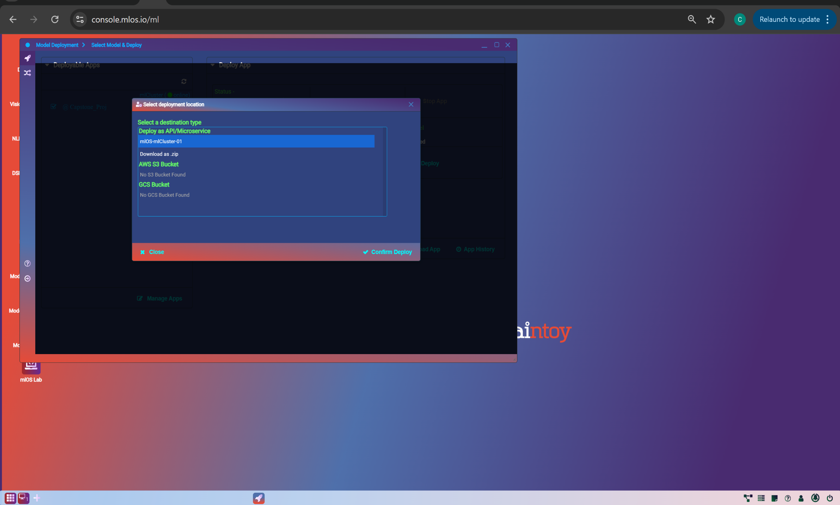***Choosing a Deployment Location:** The next step is to define where the model should be deployed. This involves selecting a destination type. In our case, since we're working within an MLS Cluster, this will serve as our deployment destination.Other deployment options typically include services like AWS S3, Google Cloud Storage (GCS), and similar cloud-based destinations. We select MLS Cluster, confirm the deployment, and the model is officially deployed and ready for use.

**Select Deployment Location**

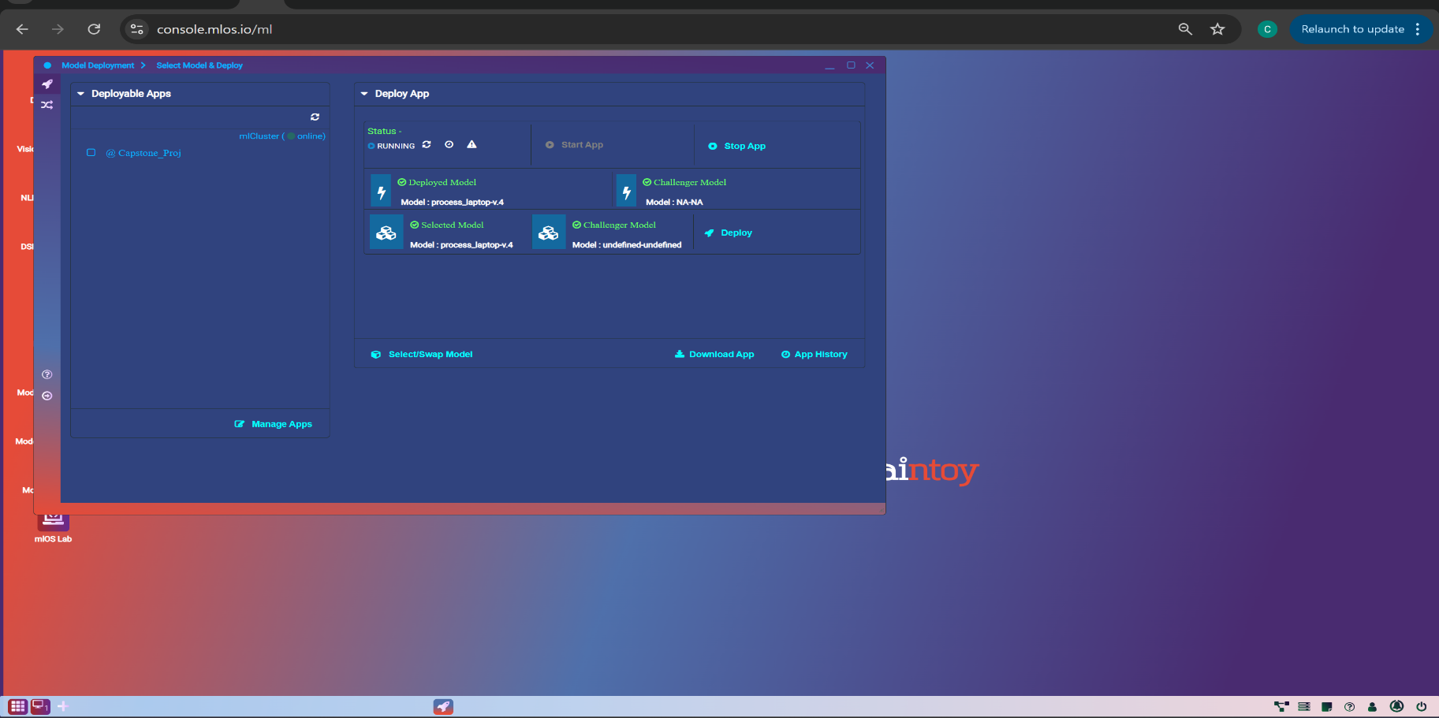

**Model Deployed.**

* 1. **App Dashboard and Model Testing**

We can now click on the App Dashboard to access the live view of the deployed app. This dashboard provides an overview of app activity, prediction logs, input/output behaviour, and other relevant information.To test the model, we changed the input value for Inches to 16, while selecting features such as Apple, Ultrabook, and MacOS. The deployed Random Forest model successfully predicted a laptop price of 58,505.35, showing that the model is operational and responsive to new inputs.

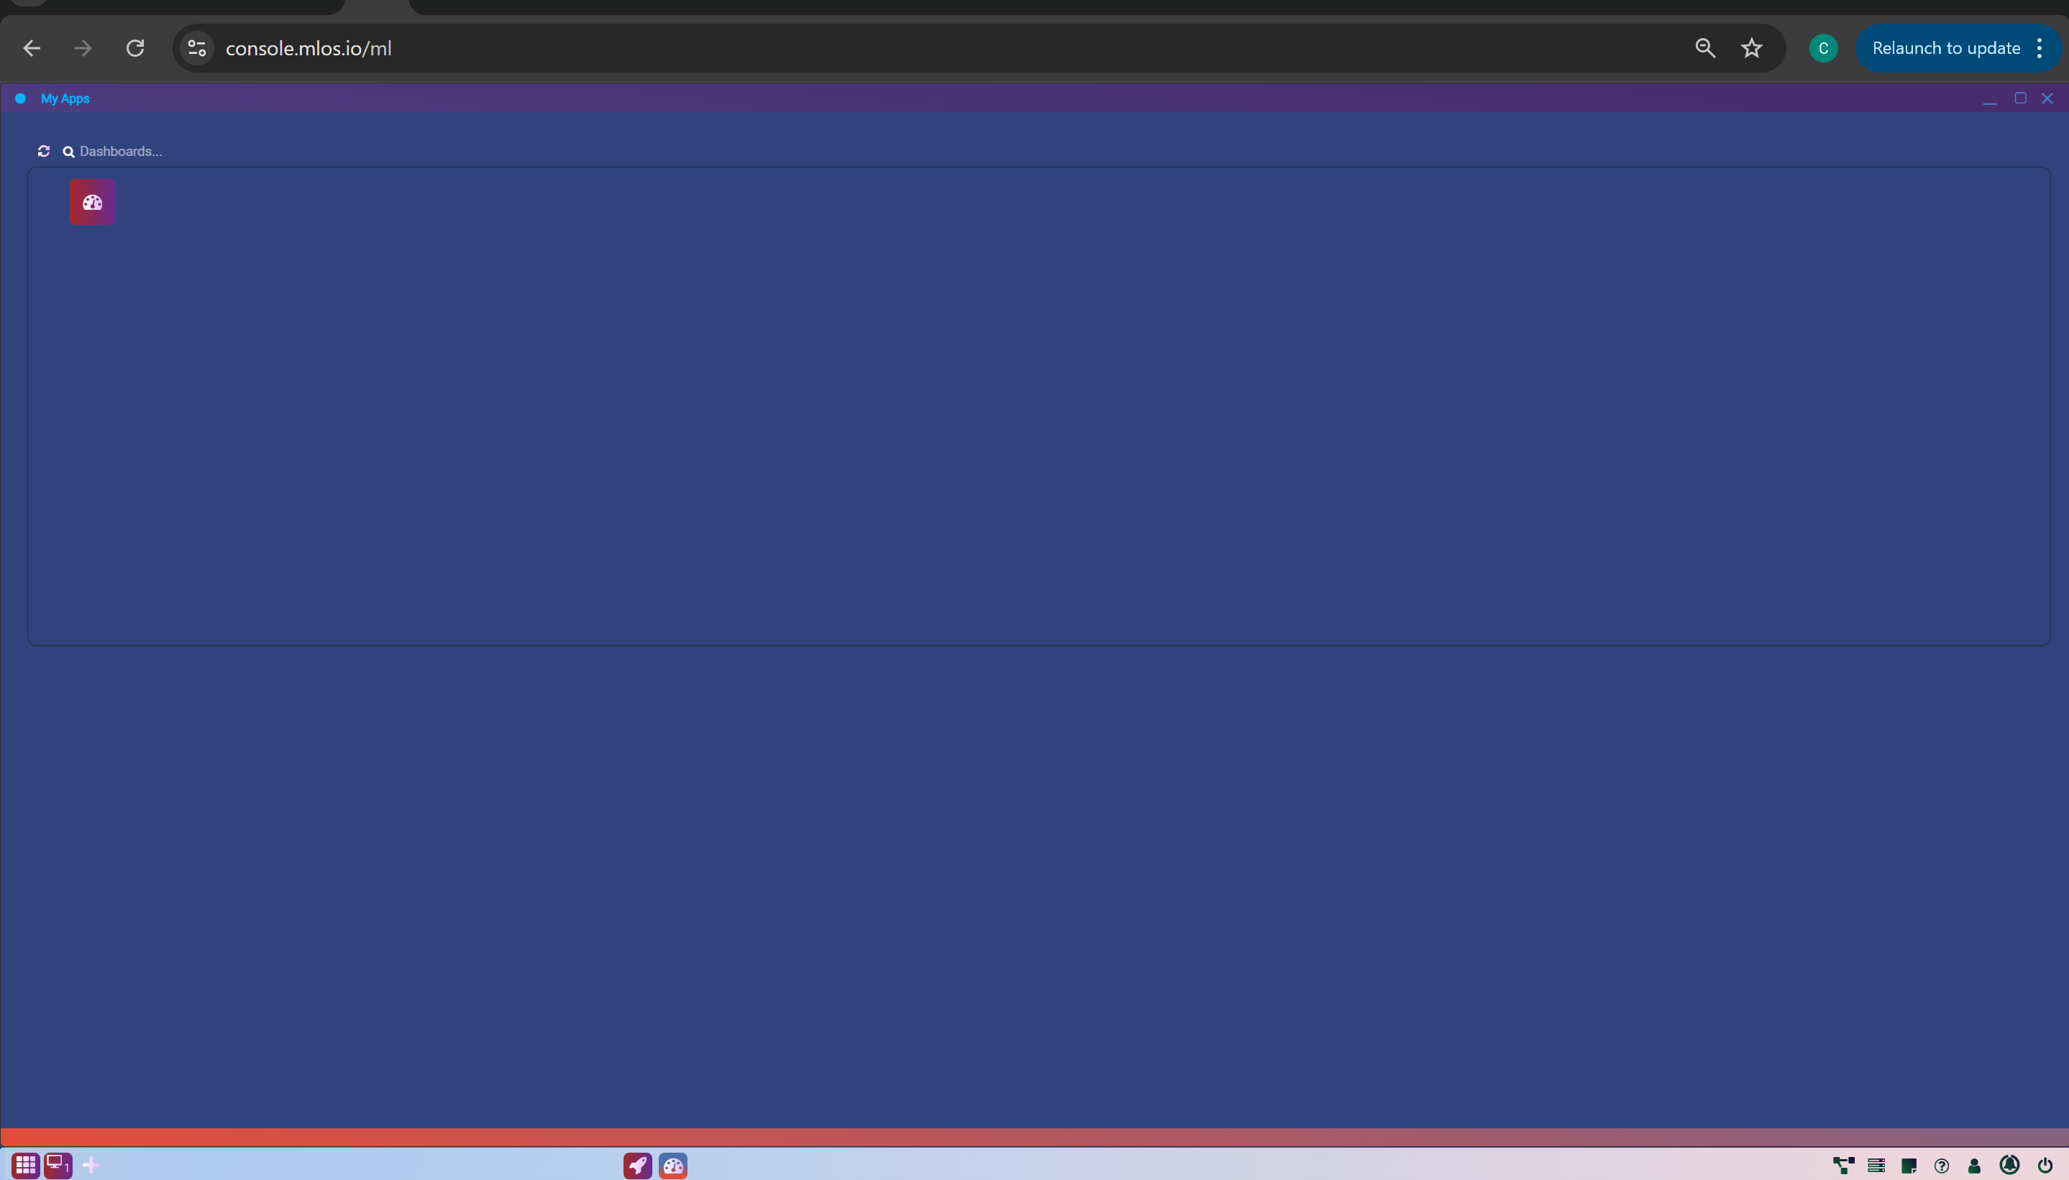

**App Dashboard**

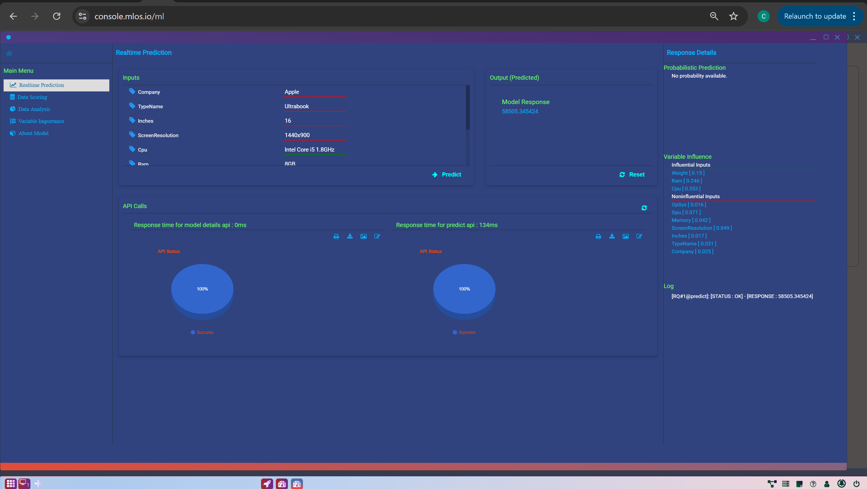

**App Dashboard (a)**

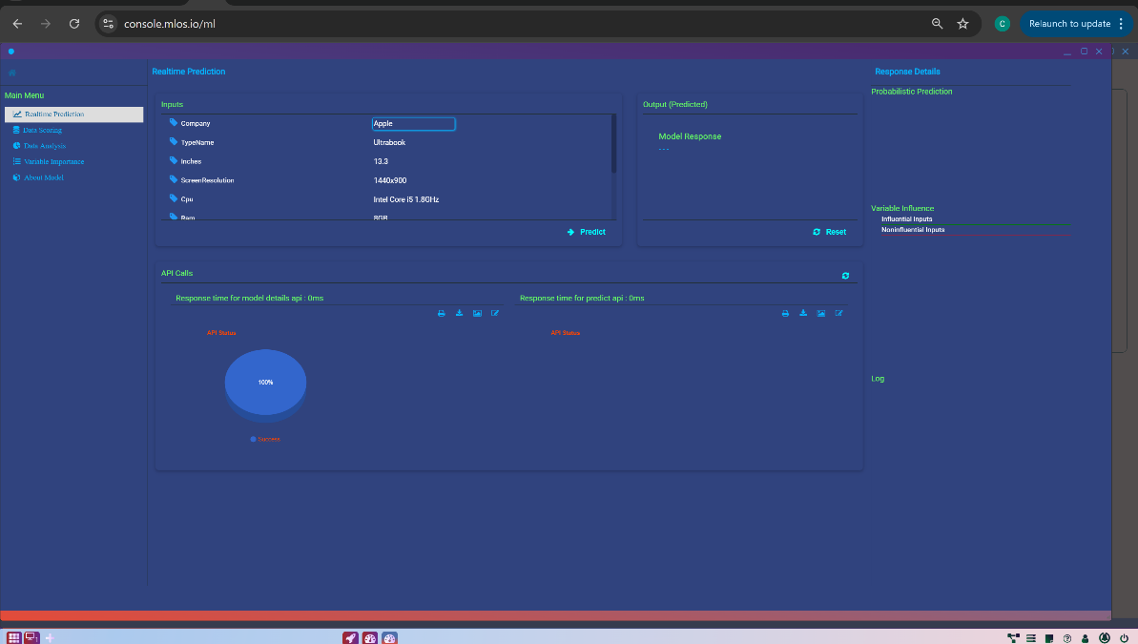

**App Dashboard (b)**

**5. Conclusion:**

**5.1 How could an organization or institution implement or use this solution?**

An organization—such as an e-commerce platform, electronics retailer, or supply chain manager—can implement this laptop price prediction model to streamline pricing strategies, offer price recommendations, and monitor market trends. By integrating the model into a real-time web or internal dashboard, businesses can:

* Predict fair market prices for new or incoming laptop inventories.
* Recommend price ranges to customers or partners.
* Detect over- or under-priced listings on their platform.
* Use the model as a baseline valuation tool for trade-in programs or refurbished products.

Educational institutions could also use it as a **teaching resource**, demonstrating real-world machine learning applications in product pricing and decision-making.

**5.2 Lessons Learned & Opportunities for Improvement**

Several key lessons emerged during this project:

* Data quality and preprocessing play a critical role in the success of any model. Issues like inconsistent formatting (e.g., RAM or Memory units), missing values, or ambiguous entries had to be carefully handled.
* Tree-based algorithms like Random Forest showed strong performance, highlighting the value of ensemble methods in regression tasks.
* Model interpretability is essential when presenting results to stakeholders—tools like feature importance and SHAP values can improve trust in predictions.

**5.3 Areas for Improvement:**

* Expand the dataset to include more diverse laptop types, brands, and specifications to improve model generalizability.
* Incorporate external data sources, such as market trends, customer ratings, or historical pricing, to make the predictions more dynamic and context-aware.
* Deploy the solution as a full-fledged web app or API with user authentication, data logging, and monitoring for real-world usage.
* Evaluate additional algorithms (e.g., Gradient Boosting, XGBoost) and perform hyperparameter tuning for even better results.

1. **Appendix:**
   1. Reading laptop data file using jupyter notebook and python script

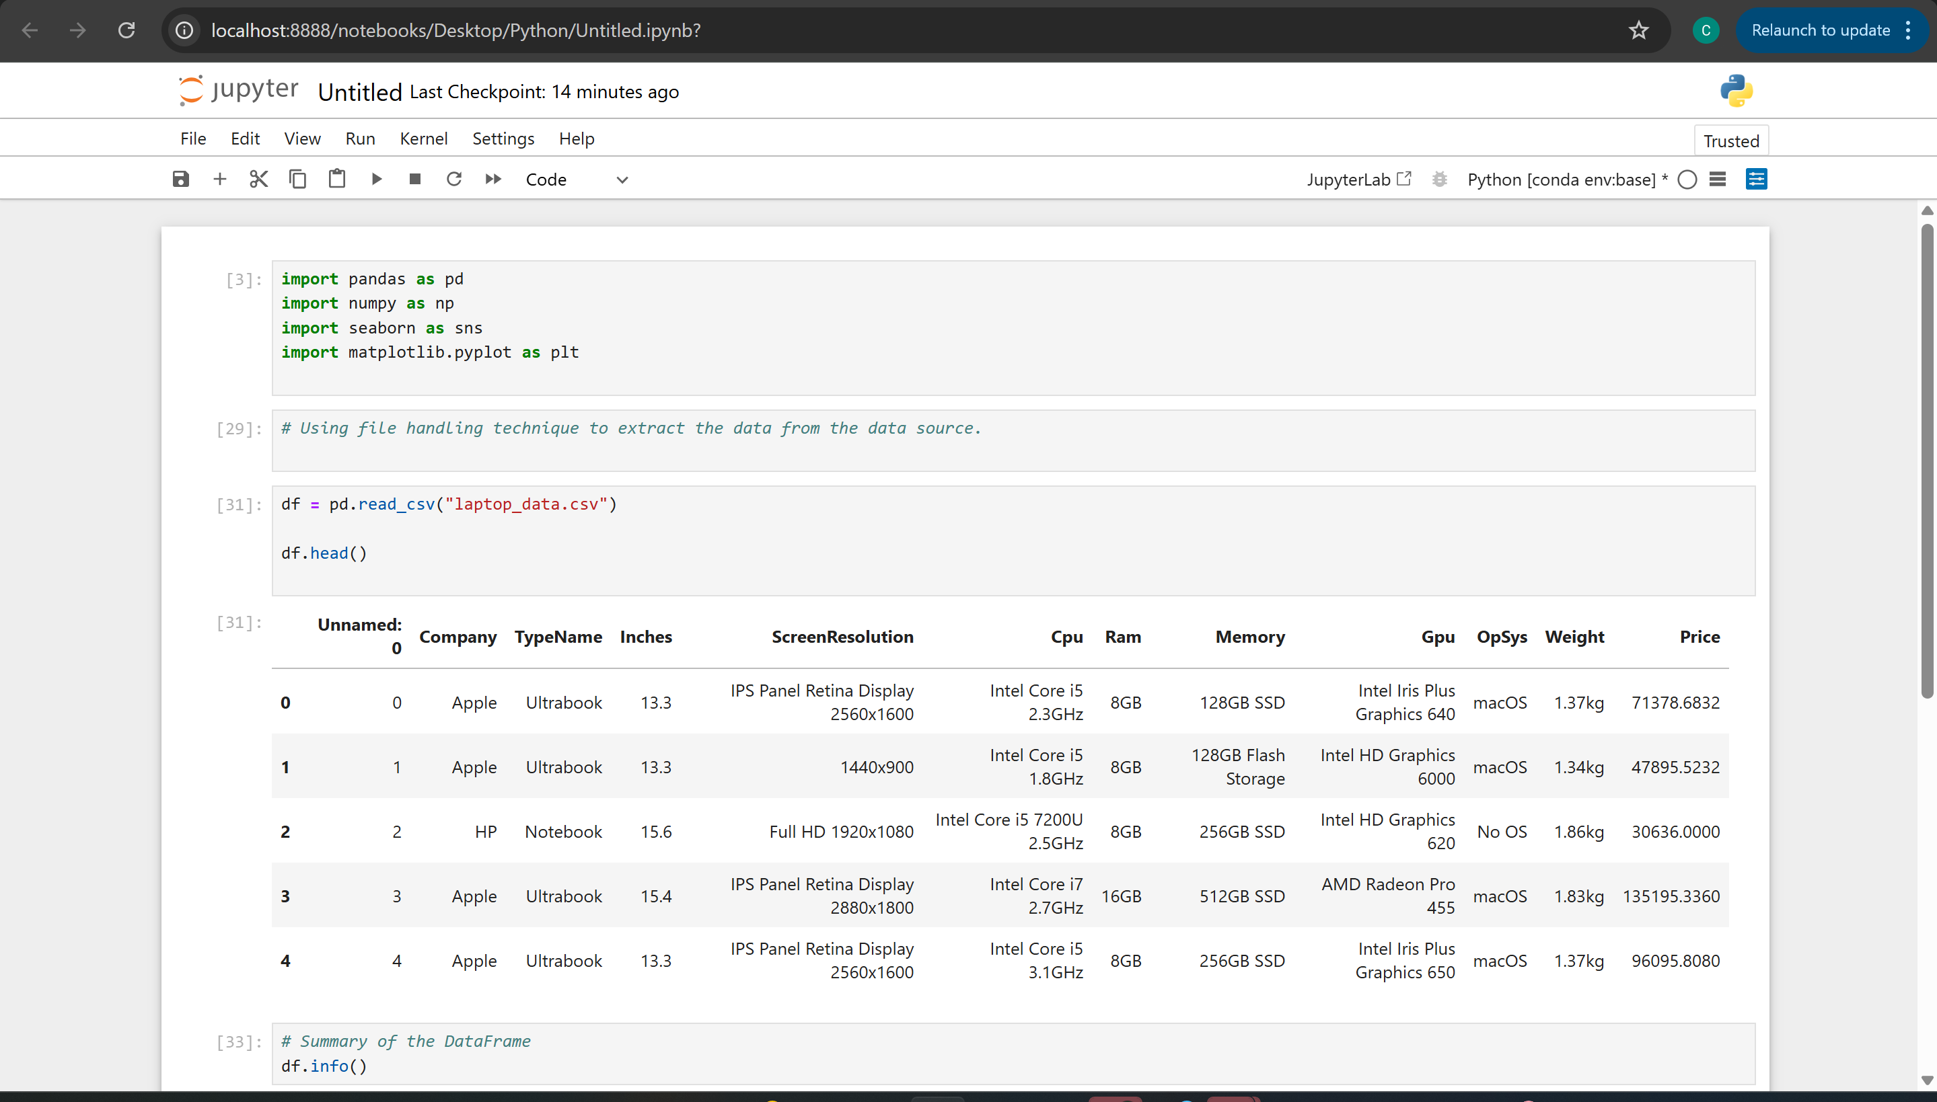

* 1. Examining the datatype

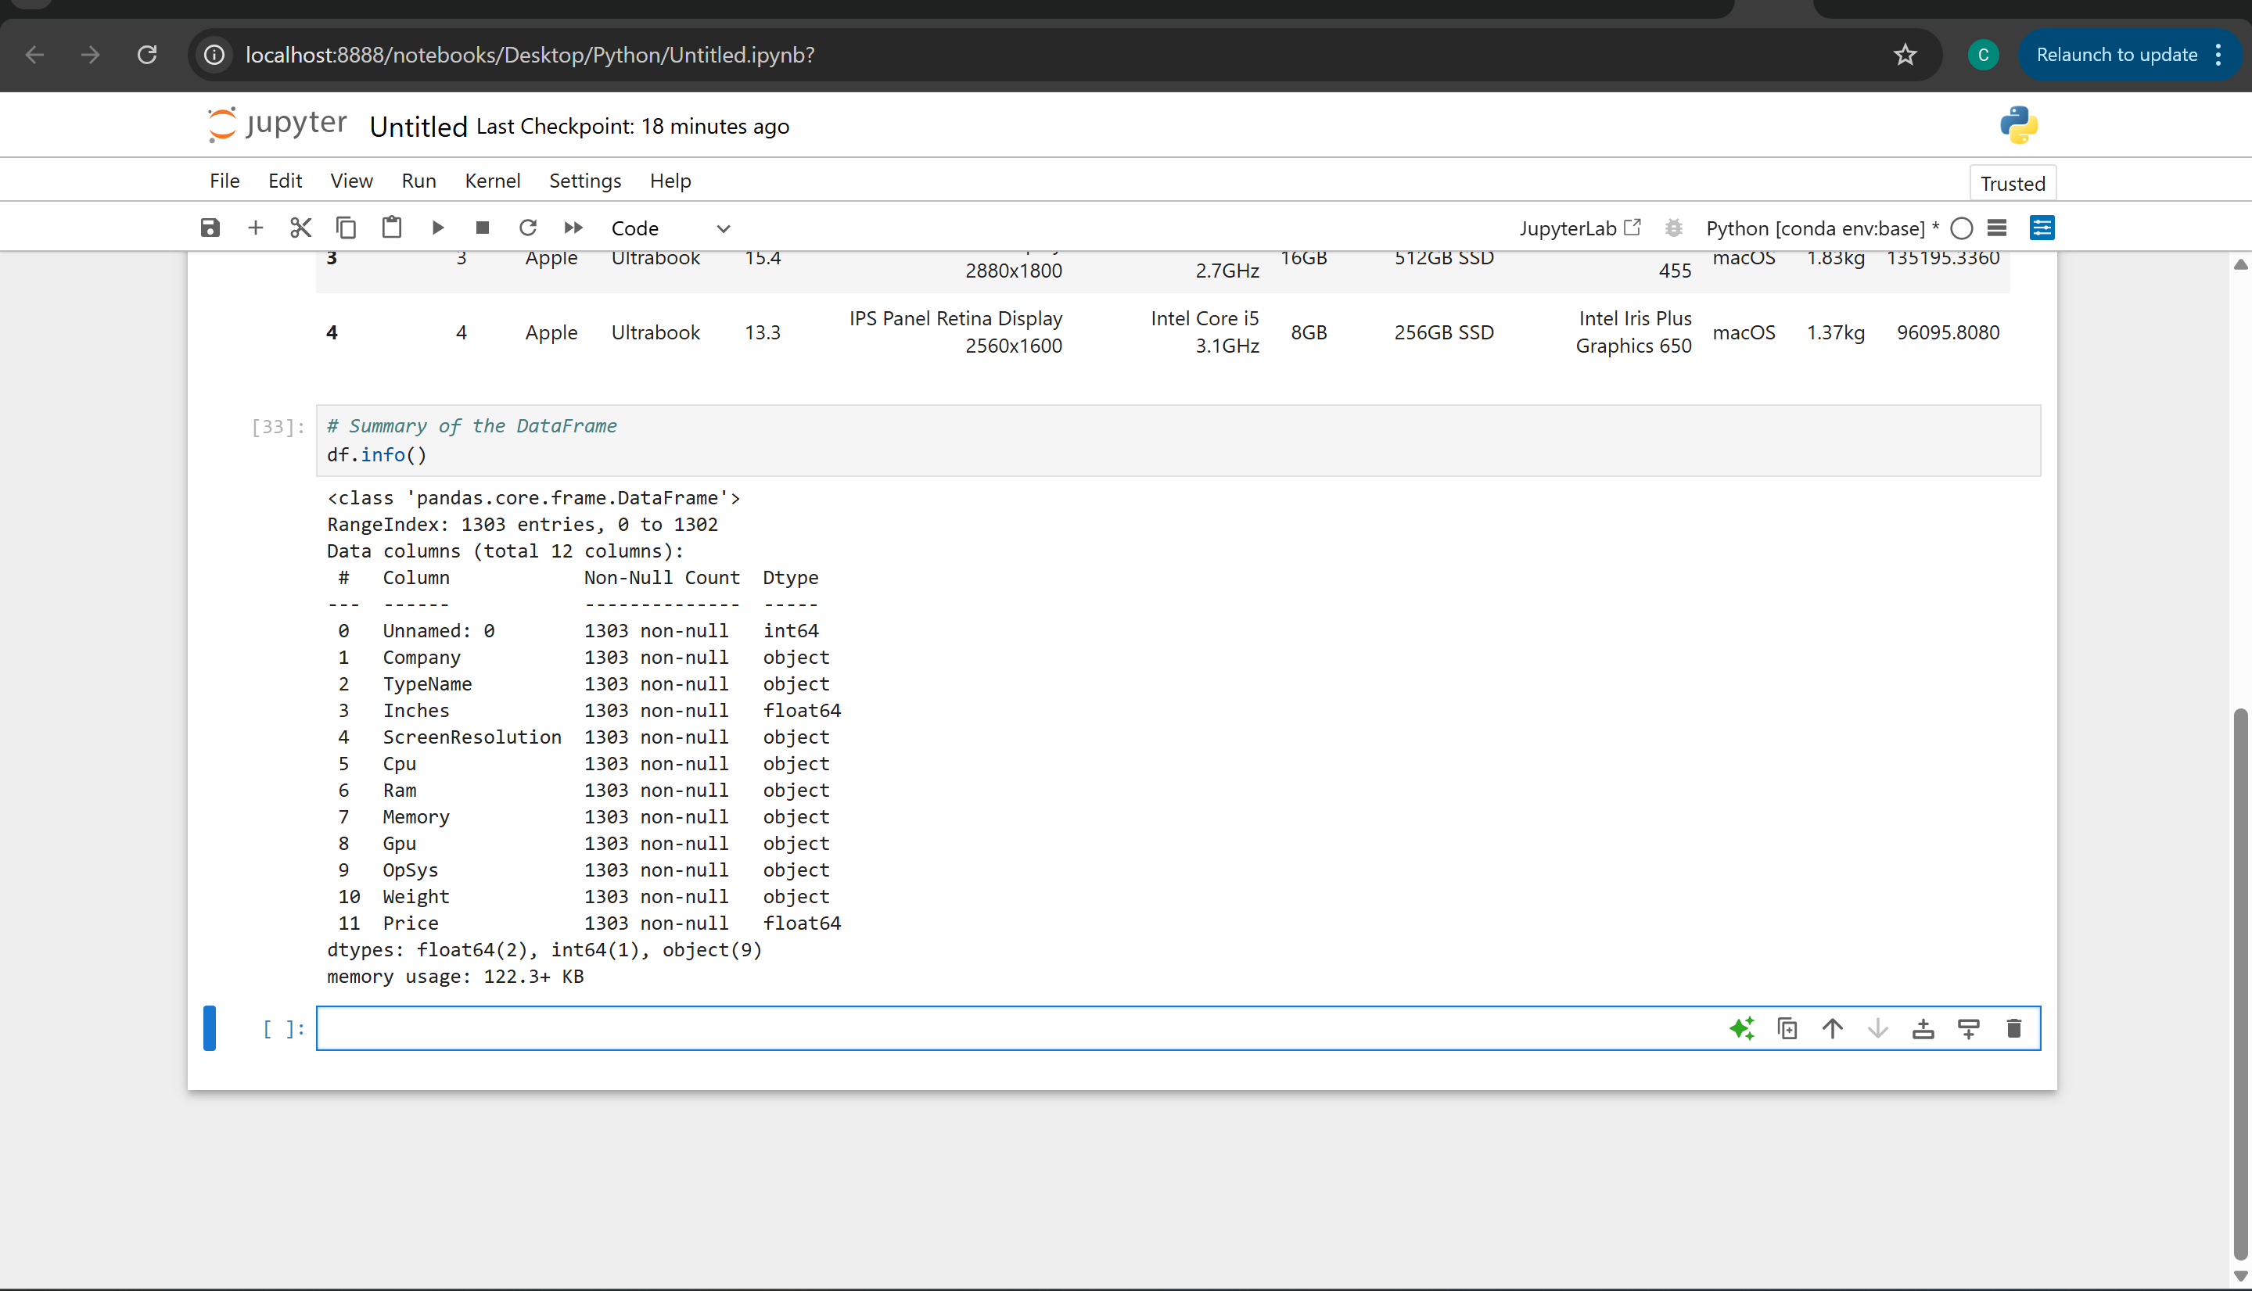

6.3 Checking for NULL values

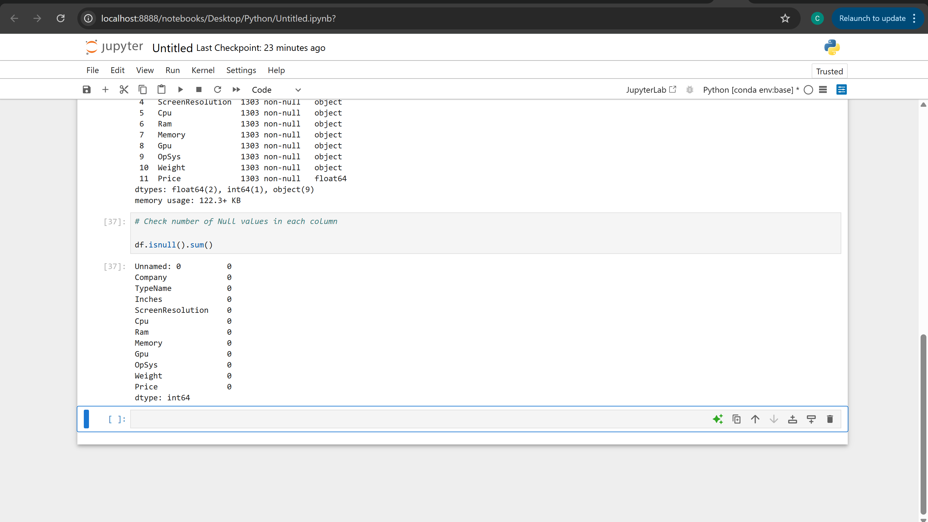

6.4 Data distribution of laptop Price and RAM using boxplot to view outliers

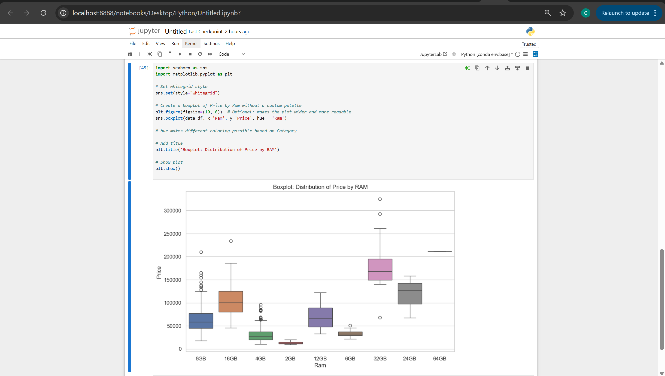

**Reference**

* [**https://developer.ibm.com/articles/architectural-thinking-in-the-wild-west-of-data-science/**](https://developer.ibm.com/articles/architectural-thinking-in-the-wild-west-of-data-science/)
* [**https://scikit-learn.org/stable/modules/generated/sklearn.ensemble.RandomForestRegressor.html**](https://scikit-learn.org/stable/modules/generated/sklearn.ensemble.RandomForestRegressor.html)
* [**https://www.ibm.com/think/topics/random-forest**](https://www.ibm.com/think/topics/random-forest)
* ChatGPT
* [**https://www.console.mlos.io/ml**](https://www.console.mlos.io/ml)by Braintoy